**March 28, 2019**

**Version 1.0**

**Proposal Author:** Brian Carusella

**Problem Summary:** A simple report is required for stores to monitor the progress of shelf scan inventory; specifically, an at-a-glance view of which shelves have and have not been full scanned.

**Who will use this report:** Store management, DIMs and DMs will use it to monitor the progress of scanning for physical inventory.

**Priority:** Ideally this report would be ready for testing prior to physical inventory June 2019.

**Report testing:** This report can be tested any time. It will likely be tested by the Operations Department.

**Solution Summary:** The report can be run for a given store and date range. The report indicates, in as near to real time as possible, a list of all active shelves, highlighting which shelves have been full or single scanned within the date range selected, and how many items have been scanned to that shelf within the date range. Optionally it can display totals for all Sections, based on Shelf Scan Subject, along with last full scan date, percentage of active shelves full scanned, and percentage of active shelves single scanned.

1. The report menu has seven selections
   1. Location number, selected from a list box
   2. Start date, selected from a calendar box
   3. End date, selected from a calendar box
   4. Report type. This is a dropdown selection. The report can be run by Shelf or Section
   5. Section filter. This can be set to “ALL” (default) or to a specific Shelf Scan section.
   6. Scan status filter. Allows the report to be filtered by
      1. **All** active shelves
      2. **Full** scanned active shelves only (for the reporting period)
      3. **Not full** scanned shelves only (shelves with no scans or only single scans for the reporting period)
   7. An “Inactive” shelf toggle, which results in a list of all of a stores currently inactive shelves
2. Running the report by Shelf displays a sortable list of ALL active shelf scan shelves in a store, including those that are empty
   1. Unless
      1. The section filter has been set to a specific section, in which case only active shelves in that section are displayed, AND/OR
      2. The scan status filter is set to something other than “All”, in which case only those active shelves specified by the filter are displayed
   2. The first column shows the shelf ID
      1. Shelf IDs that have been full scanned within the date range chosen are highlighted in green. Full scan takes precedence; if a shelf was both full scanned and later single scanned within the report period, it will be green.
      2. Shelf IDs that have been single scanned within he date range chosen are highlighted in yellow
      3. Shelf IDs that have not been scanned within he date range chosen are highlighted in red
   3. The second column shows the Shelf Scan Subject for the shelf
   4. The third column shows the date the shelf was last full scanned
   5. The fourth column shows the date the shelf last had a single scan
   6. The fifth column shows the total item count for items that were scanned to the shelf, full or single, within the dates selected
3. Running the report by Section displays (all columns sortable)
   1. A list of all Shelf Scan Subjects (sections) used in this store
      1. Sections where 100% of the active shelves have been full scanned within the dates selected for the report are highlighted in green
   2. The last full scan date for any shelf in that section
   3. The last single scan date for any shelf in that section
   4. Total active shelves in that section, including those that are empty
   5. Percentage of the total active shelves in that section that have been full scanned within the date range selected for the report
   6. Number of items scanned, full or single, in the section within the date range selected for the report
4. Running the report with the “Inactive Shelves Only” toggle displays a sortable list of all currently INACTIVE shelves in the store.
   1. The first column shows the Shelf ID
   2. The second column displays the Shelf Scan Subject

**Illustrations**

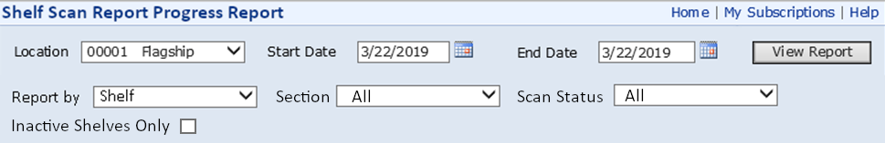

Figure 1 the Menu

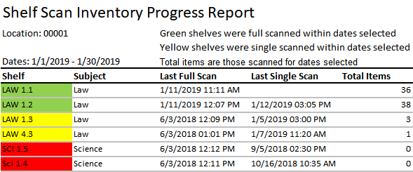

Figure 2 Report run by Shelf

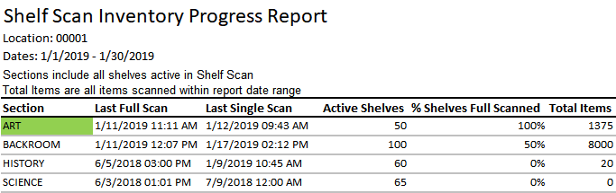

Figure 3 Report run by Section

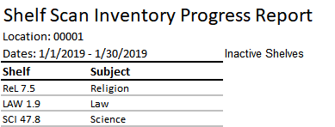

Figure 4 Inactive Shelves